**WEB SQL INJECTION SEED LAB 2.0**

Contents

Environment Setup 3

Task 1 8

Task 2 10

Task 2.1 11

Task 2.2 12

Task 2.3 14

Task 3 17

Task 3.1 21

Task 3.2 24

Task 3.3 25

Task 4 28

# Environment Setup

Adding my ID in **docker-compose.yml** file provided by SEED.

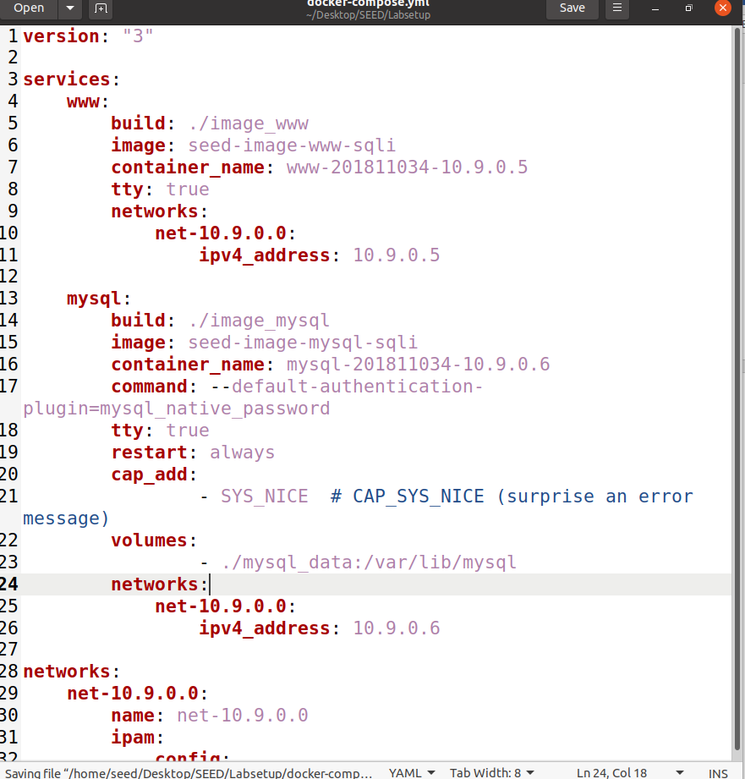

Building Dockers.

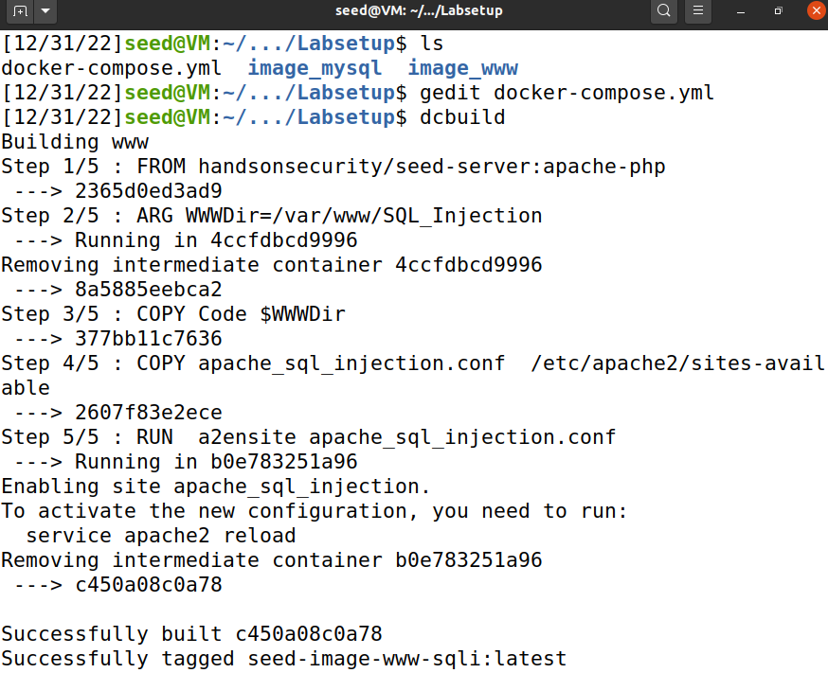2

Setting up the Containers.

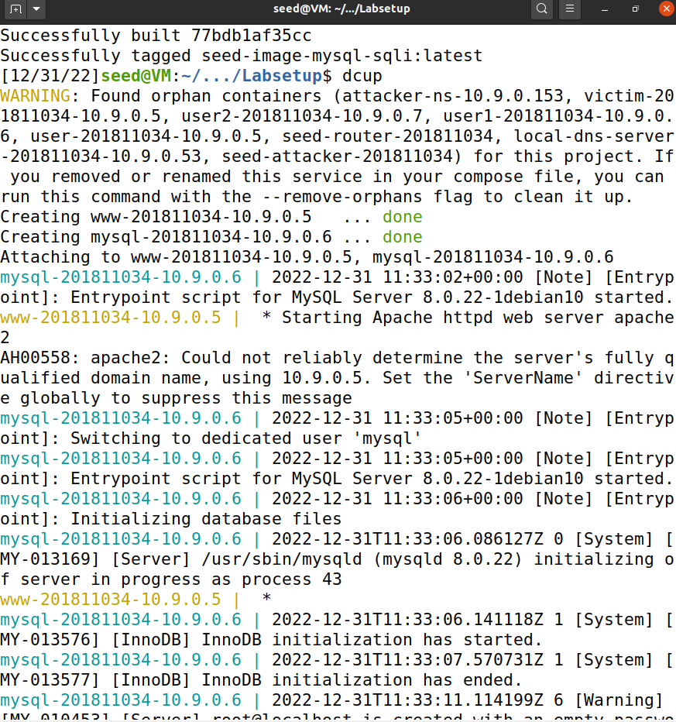

Now I copied this link as it will be required for URL of the web application.

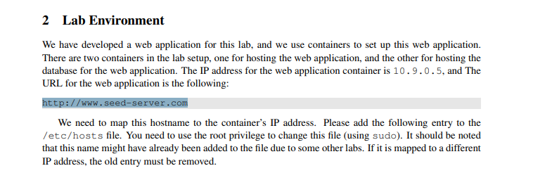

Adding the entry with the above URL.

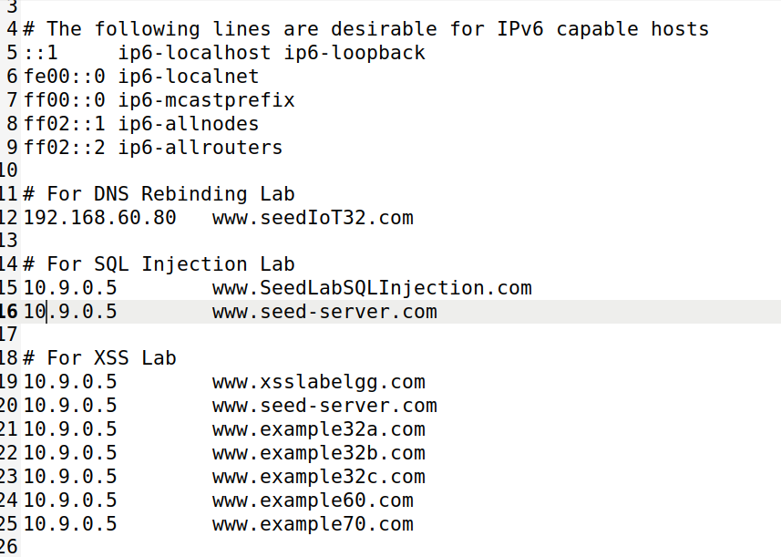

Now the URL is live.

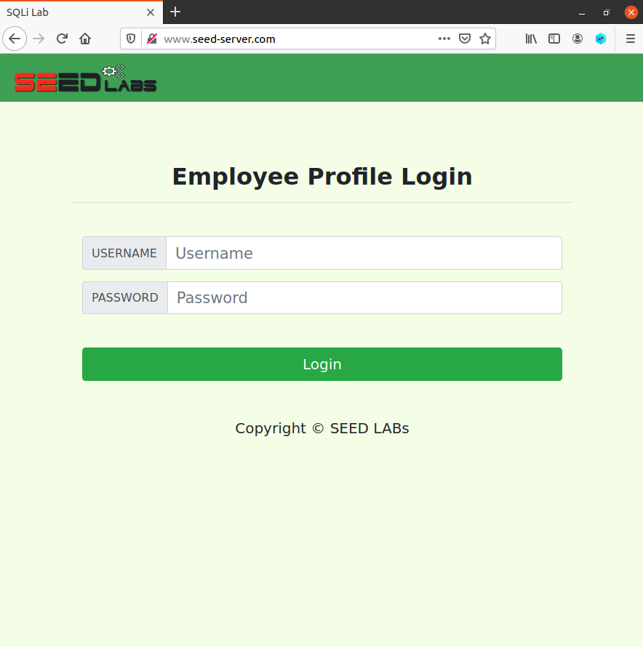

Using the provided data.

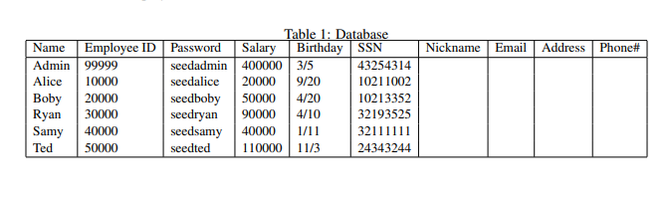

Logging in as Admin to test if the provided data works.

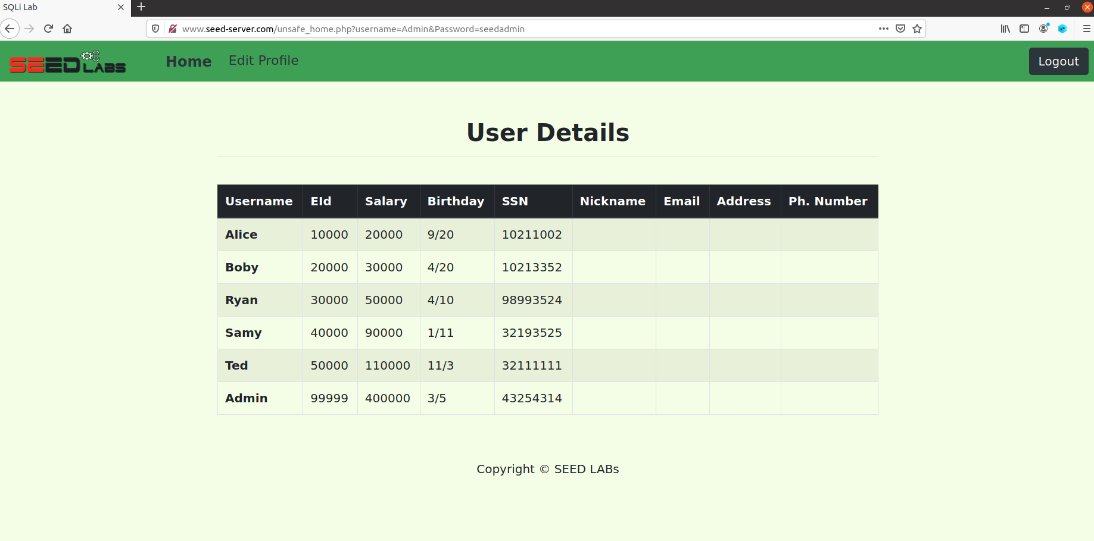

Now logging in as Alice.

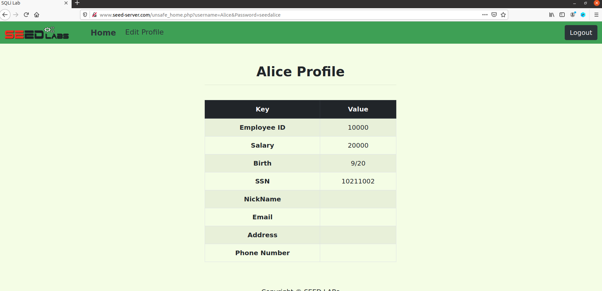

Setting up the Docker for URL.

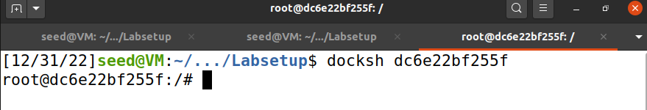

Setting up MySQL Database container.

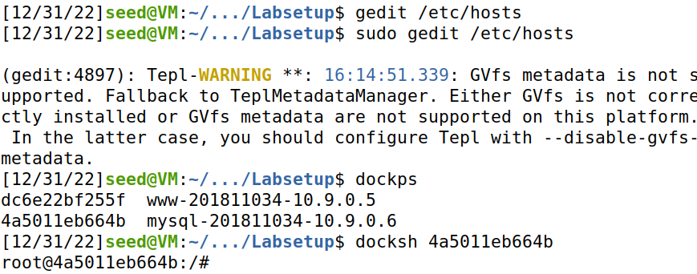

# Task 1

Checking the databases in MySQL Database where the target is “sqllab_users” as shown in the database and manual.

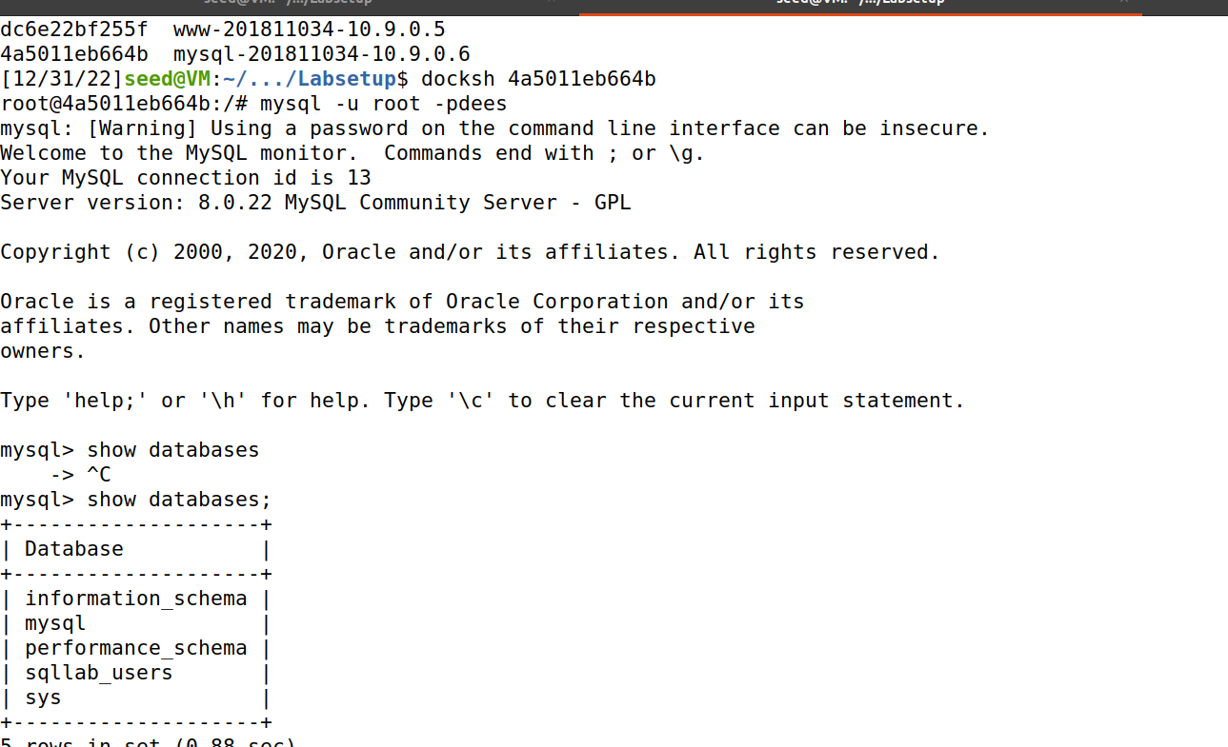

Using the target database and checking the schema of credentials table.

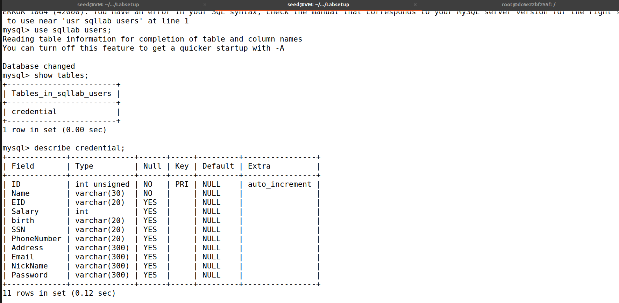

Now showing all the records with credentials of the Users where the passwords are in hashes.

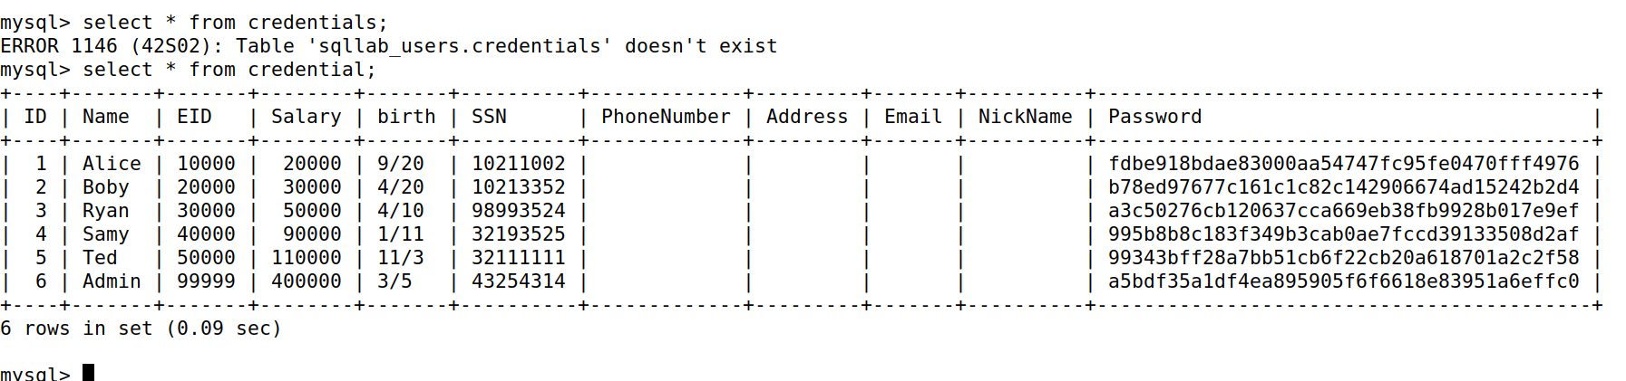

Just for verification I opened a new terminal and checked the sha1sum of the password to see if the provided password in the manual matches the one in database which it does.



# Task 2

As mentioned in the manual I am checking the **unsafe_home.php** file.

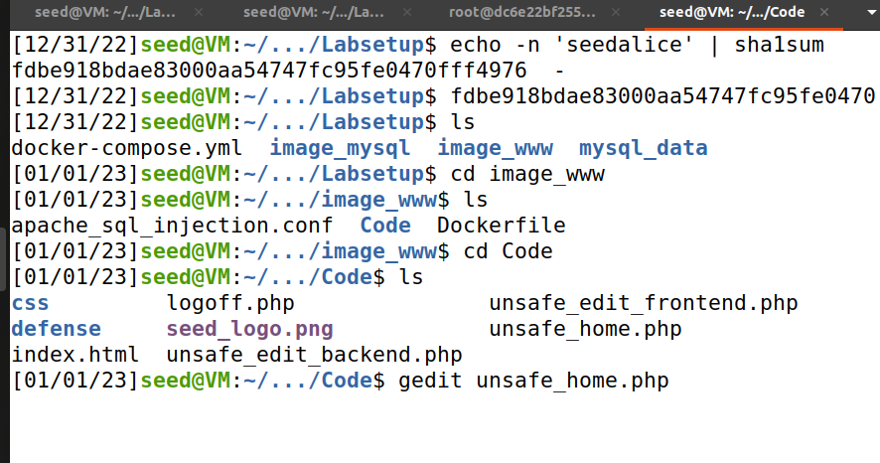

Now while looking for vulnerability I found this line which asks for parameters so I will simply added the code on line 76.

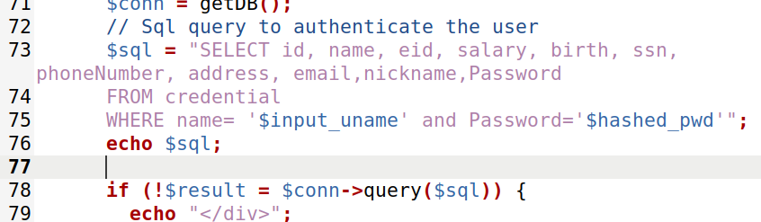

Going to the directory from the Web container to where the above file is present.

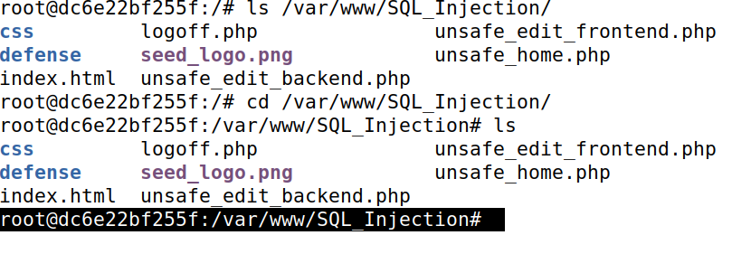

Copying the file here.

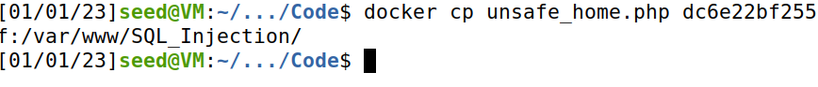

## Task 2.1

Now trying the Attack.



Now while trying to login as Admin I receive the SQL statement meaning that the input in the User section didn’t comment out the remaining section.

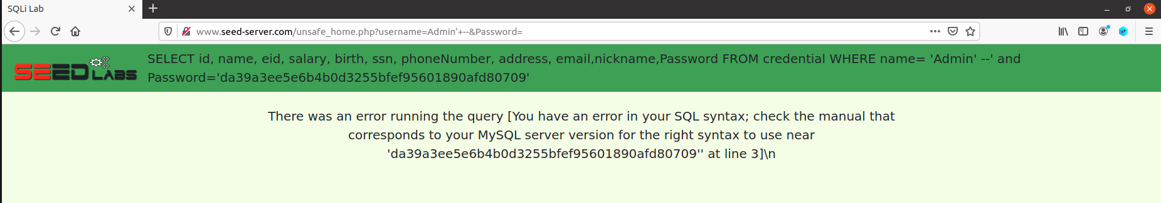

Now with the mentioned statement I got I changed the query and tried again.

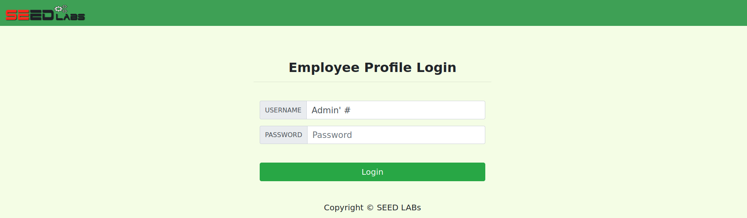

And I the attack is successful which means the query **Admin’ #** caused to comment the password section in the statement and made possible the attack.

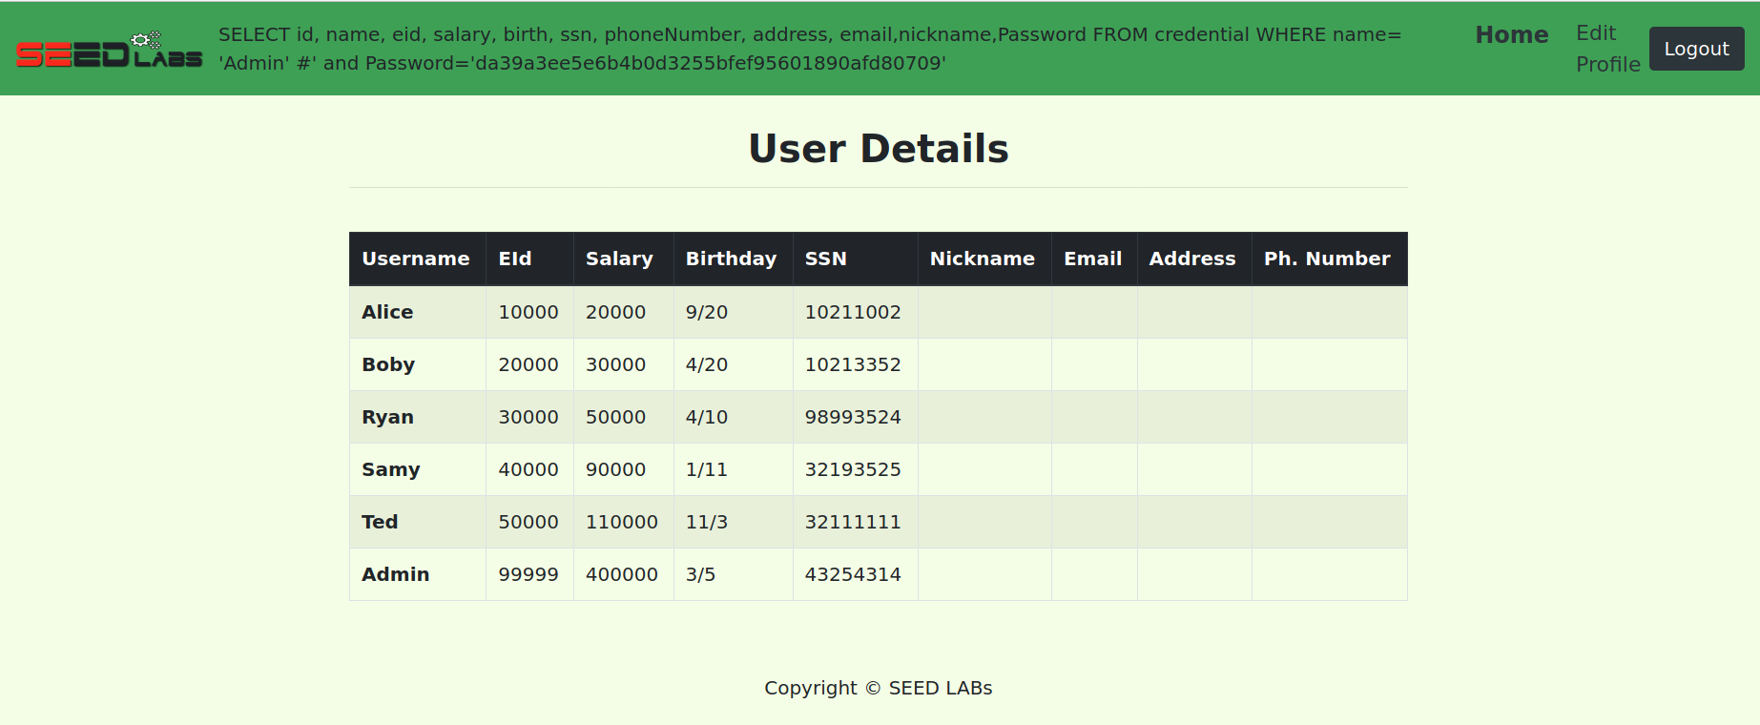

## Task 2.2

I tried the curl command **curl ’www.seed-server.com/unsafe_home.php?username=alice&Password=11’**  in the manual to get the following information but the password here is hashed. Which actually is a GET request.

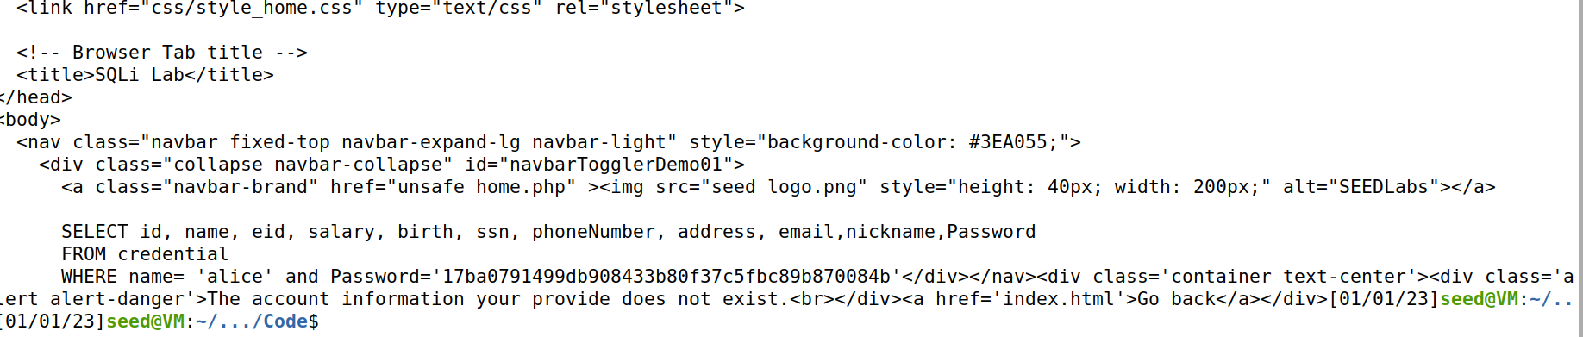

Now if I try with the provided password of Alice in the manual while using the command **curl ’www.seed-server.com/unsafe_home.php?username=alice&Password=seedalice’**. It is noticeable that the above command didn’t provide the write hashed password.

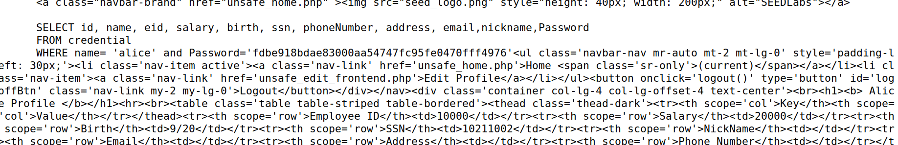

Now while trying to login without password with command **curl ’www.seed-server.com/unsafe_home.php?username=alice’ #&Password=seedalice’**. Which failed.

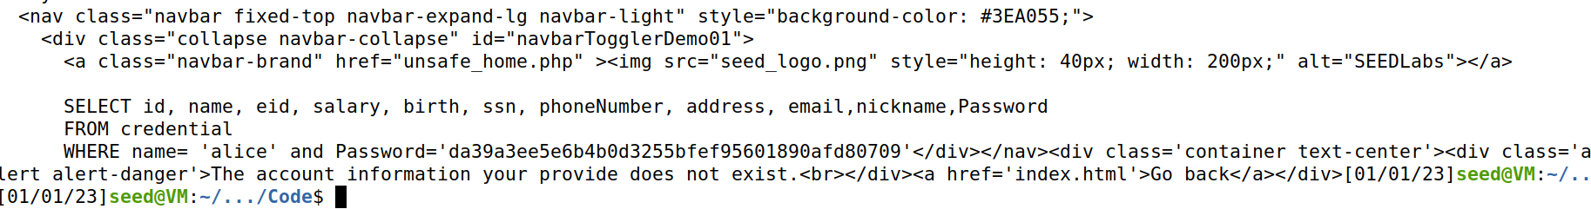

Now to make it work I encoded the displayed part below.

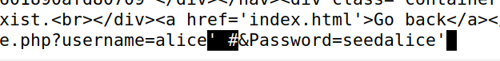

I encoded the highlighted part on the site <https://www.urlencoder.org/>.

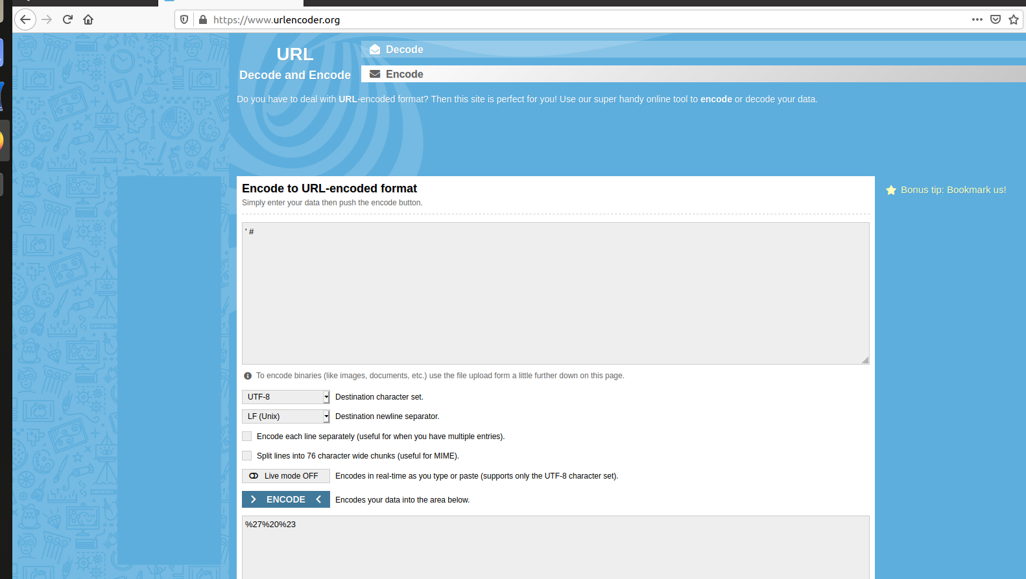

Now trying the modified command **’www.seed-server.com/unsafe_home.php?username=alice%27%20%23&Password=seedalice’** which totally worked and caused the login.

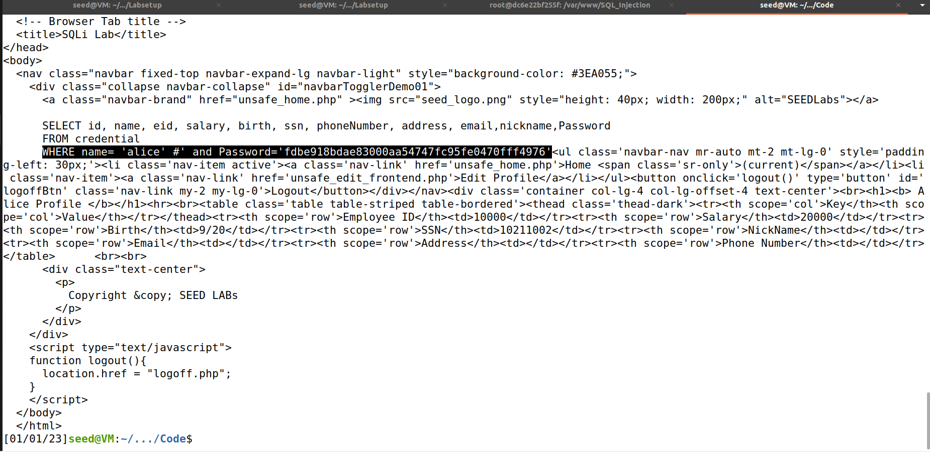

## Task 2.3

Now in the SQL Database it is possible to select 2 rows with appended SQL commands.

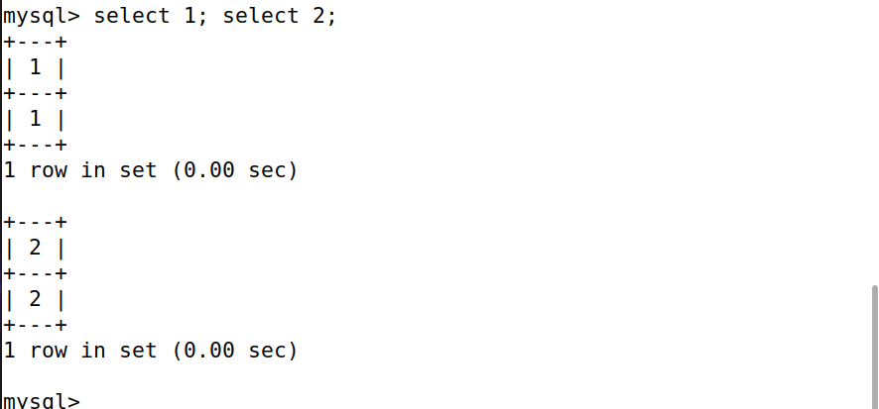

Now in the code here in line 78 there is one query allowed only.

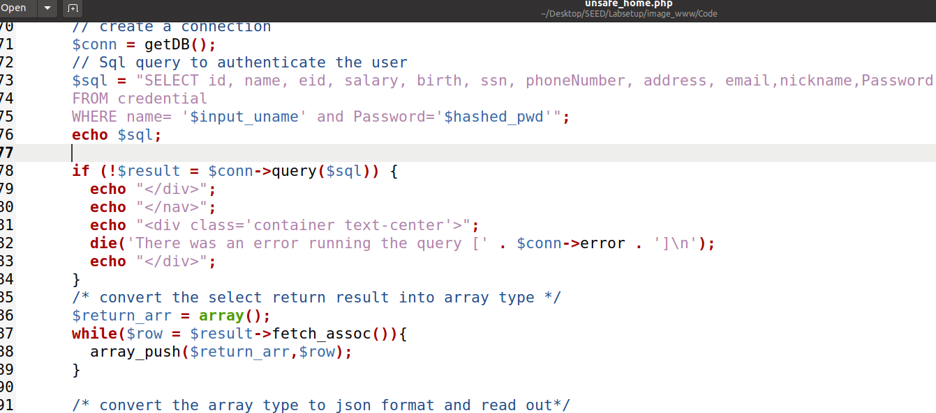

With this modification I can get around the countermeasure easily.

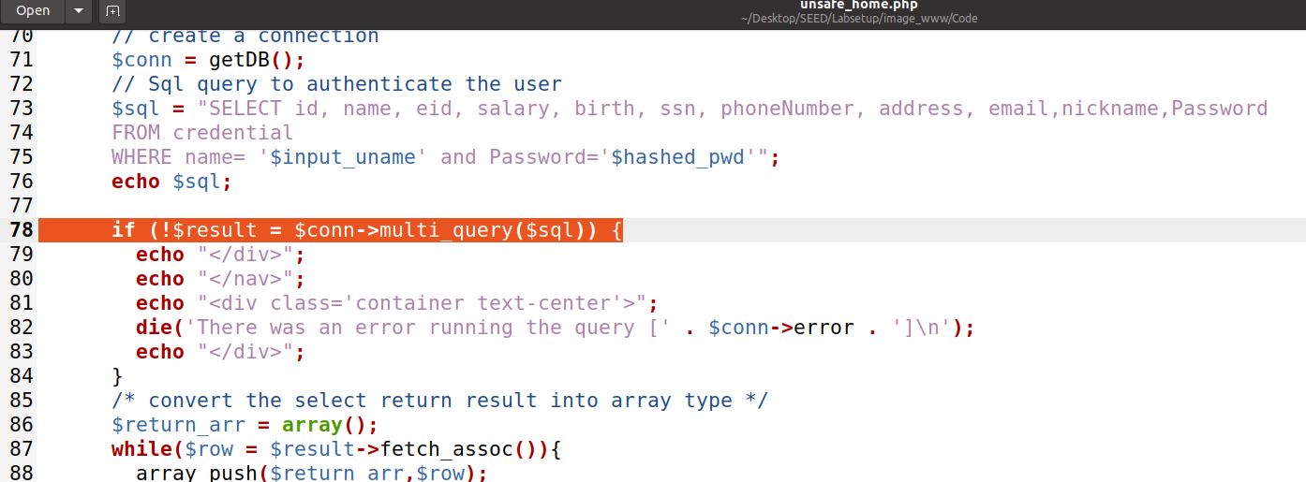

Now copying to the Web docker the code file.



Now sending the appended SQL statement.

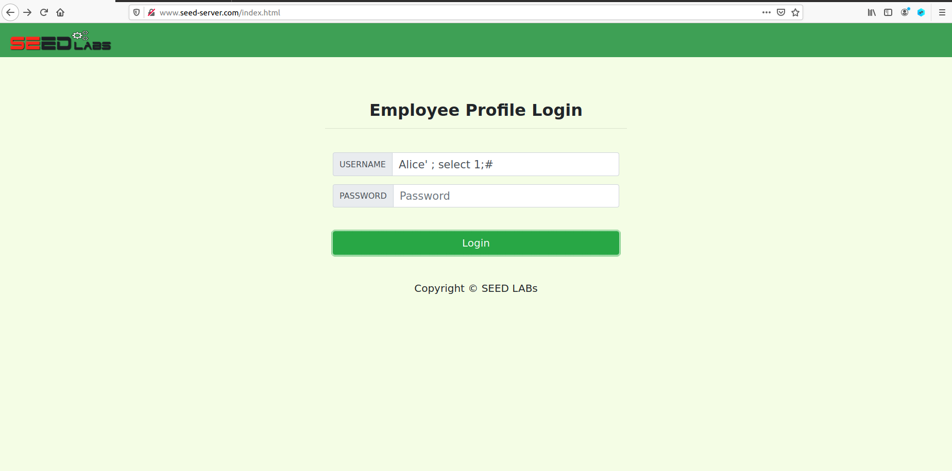

The attack worked and the reason is mentioned with the screenshot ahead.

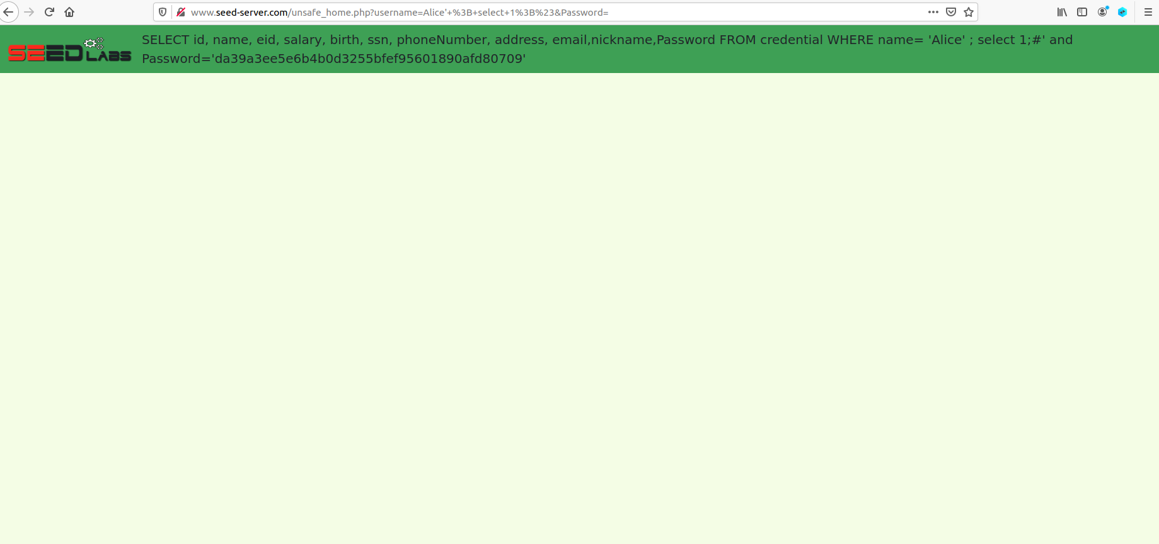

As a note that why isn’t anything displayed when I sent appended query is because the select 1 worked as the array where the data here was on the index 0 but given that with select 1 it treated as index 1 there is no data present there to show. Hence, the attack worked.

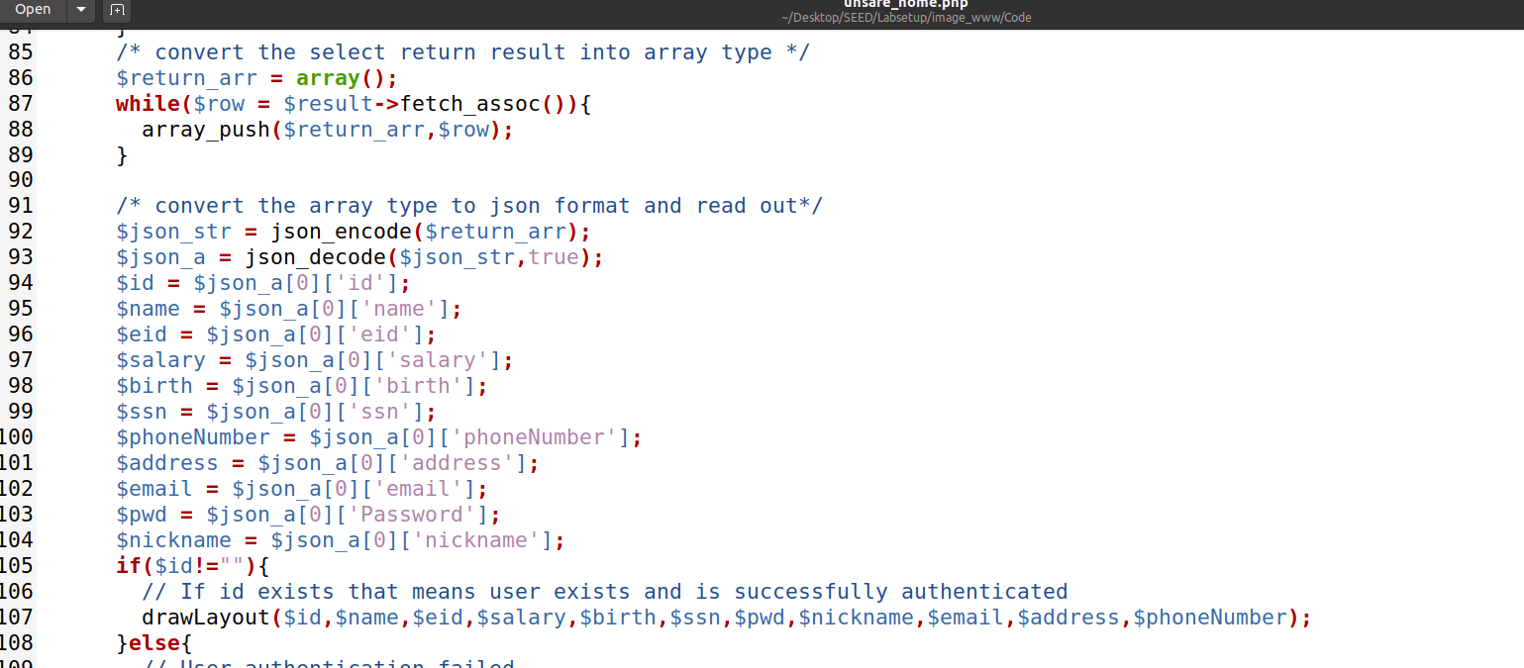

# Task 3

For the ahead tasks I removed the modifications in the home page code.

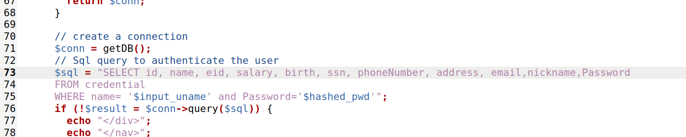

Copied the file to the Web container.



Logging in as Alice.

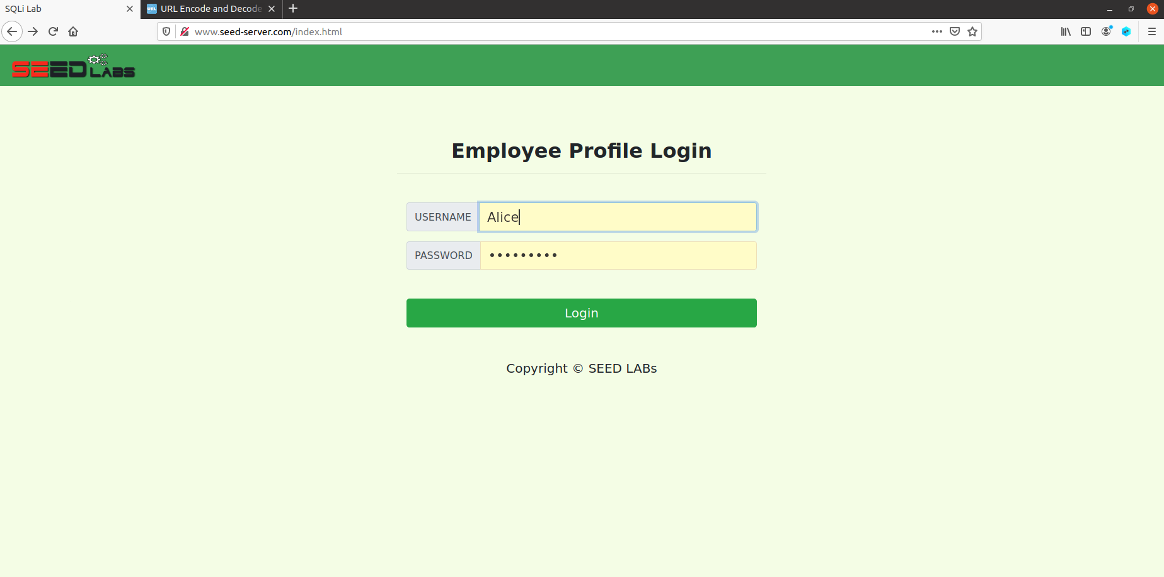

Now I am logged in as Alice.

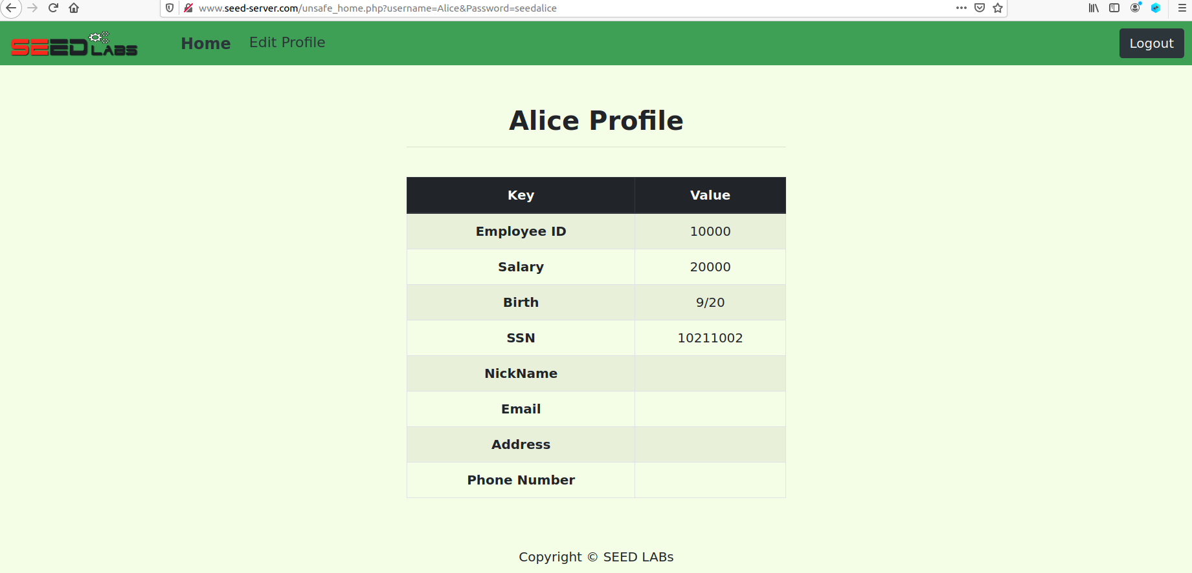

Updating the Profile of Alice.

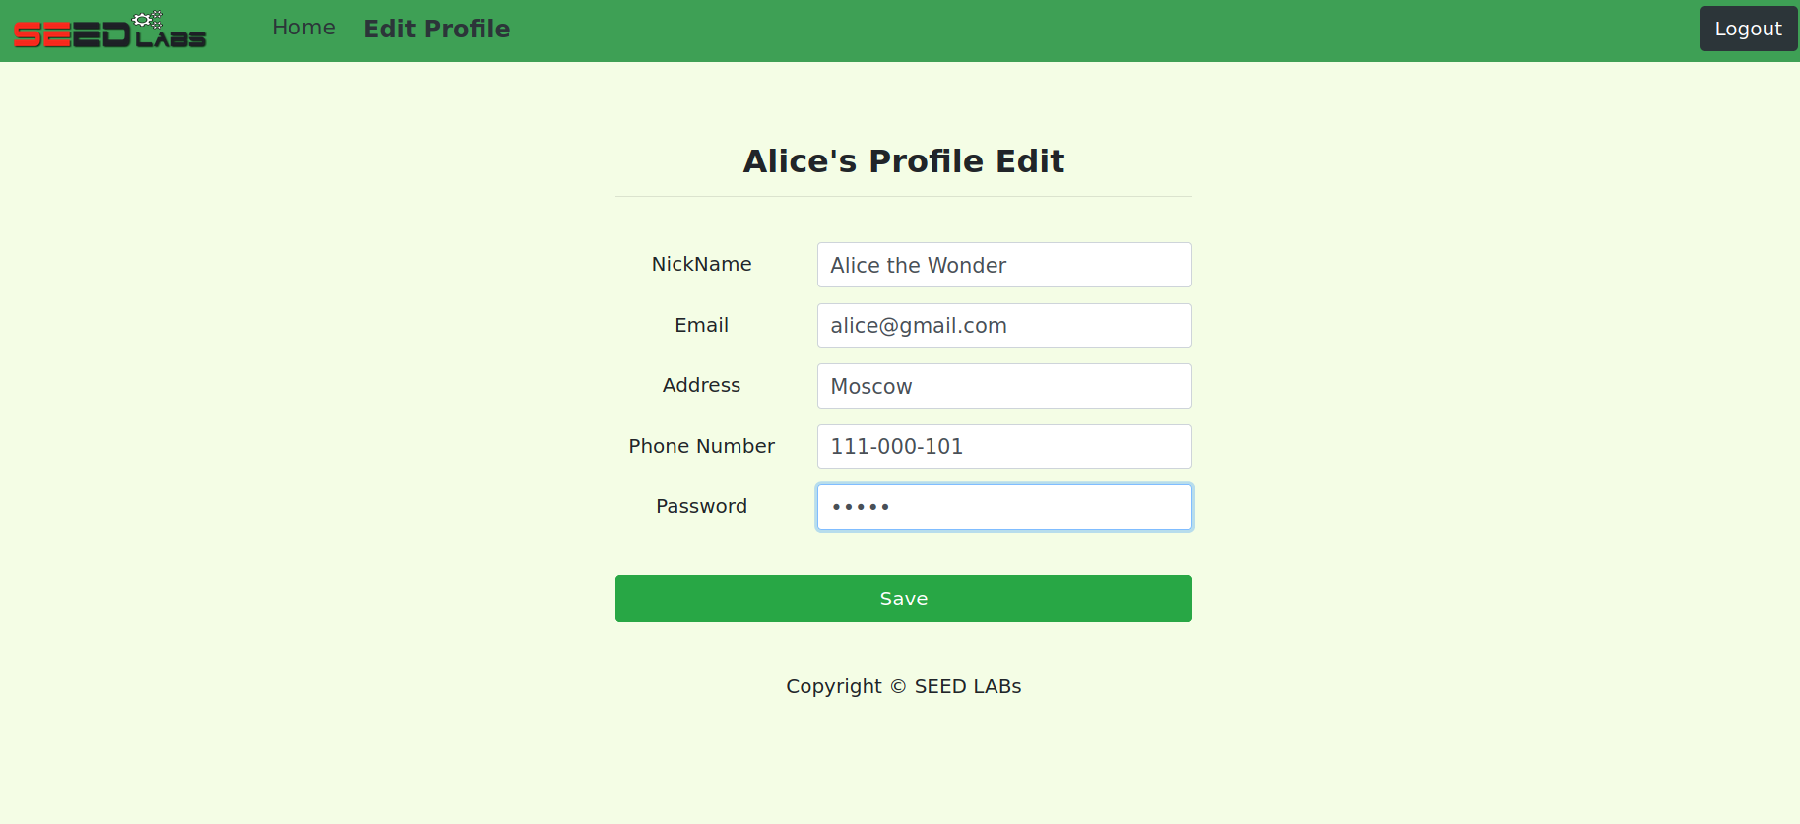

The changes are visible on the profile.

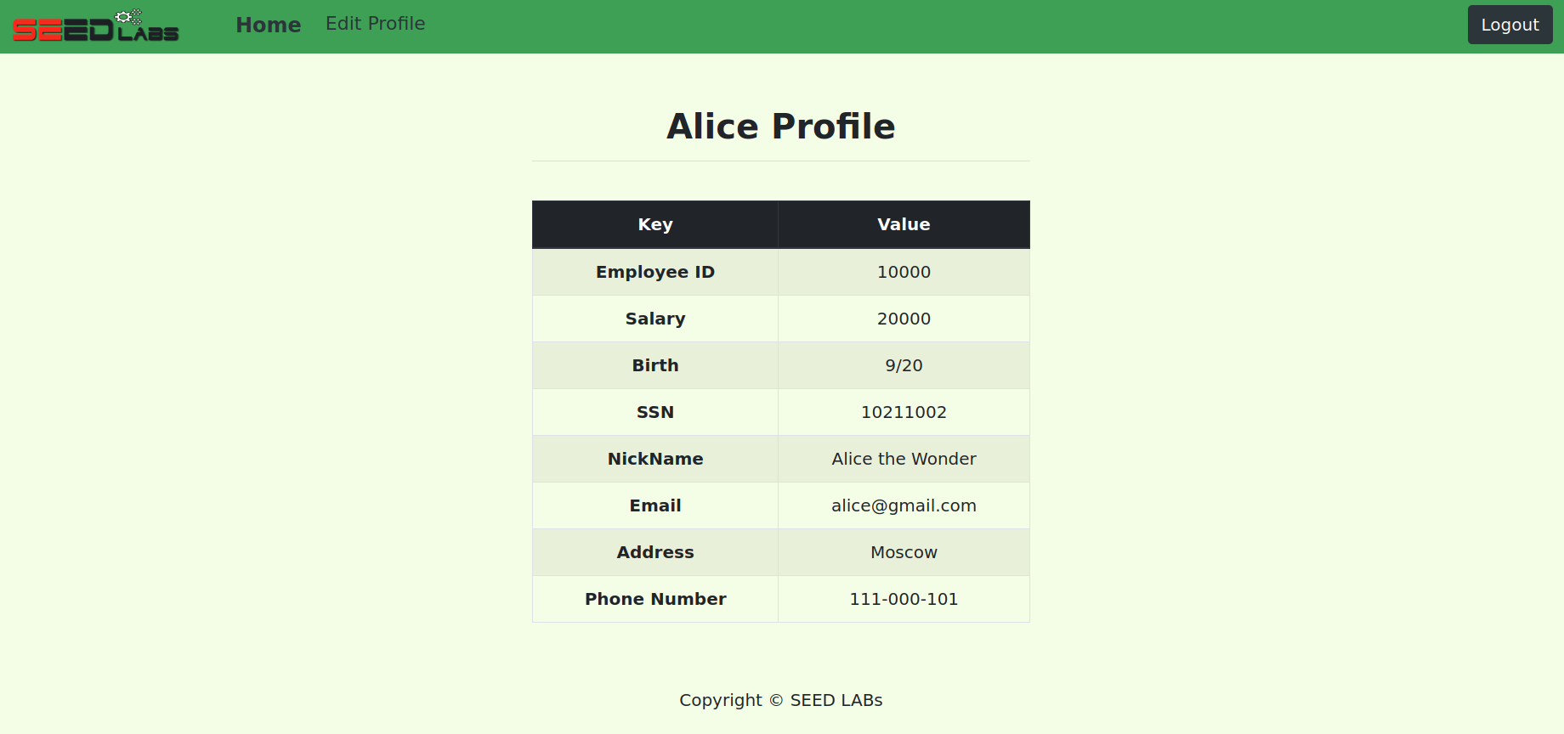

It can also be observed that the database has also been updated.

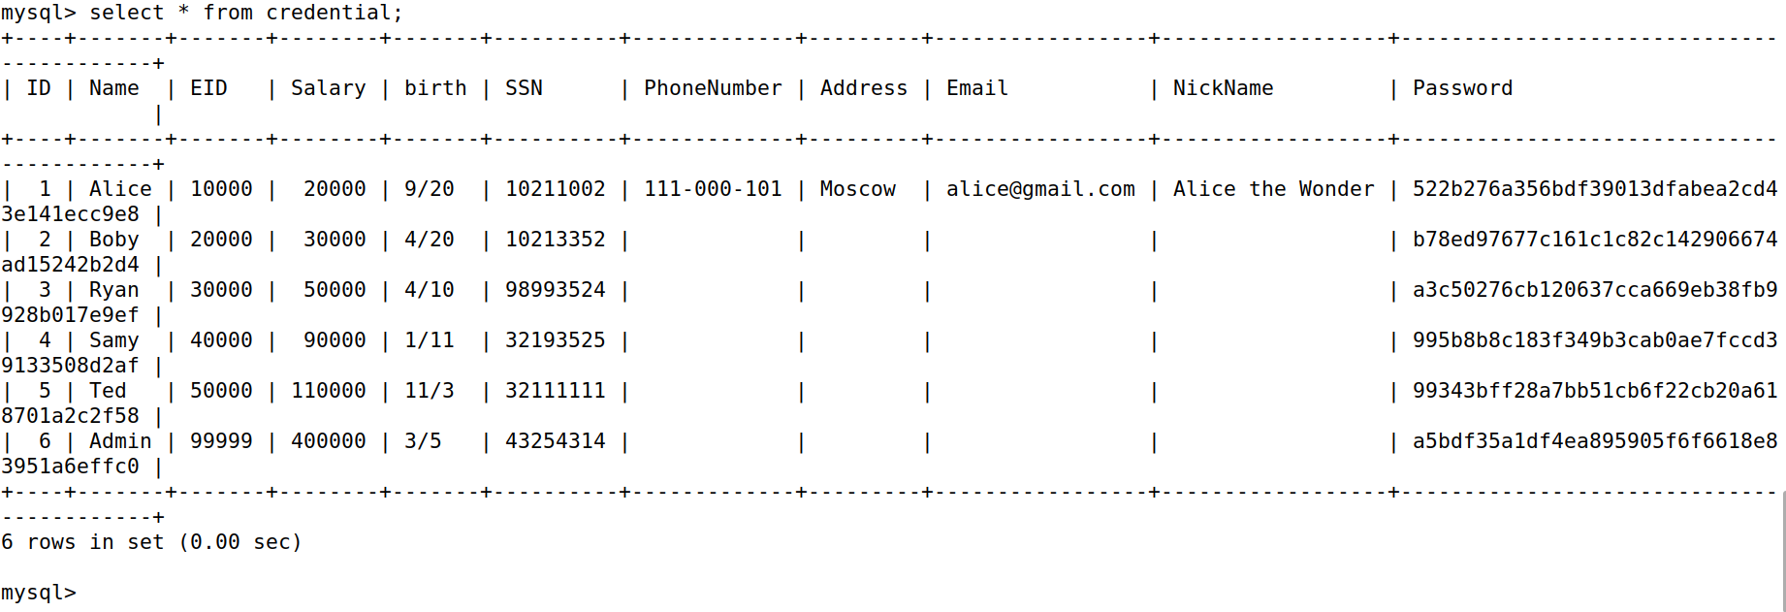

## Task 3.1

Now I modified the **unsafe_edit_backend.php** code file at line 56 and 57.

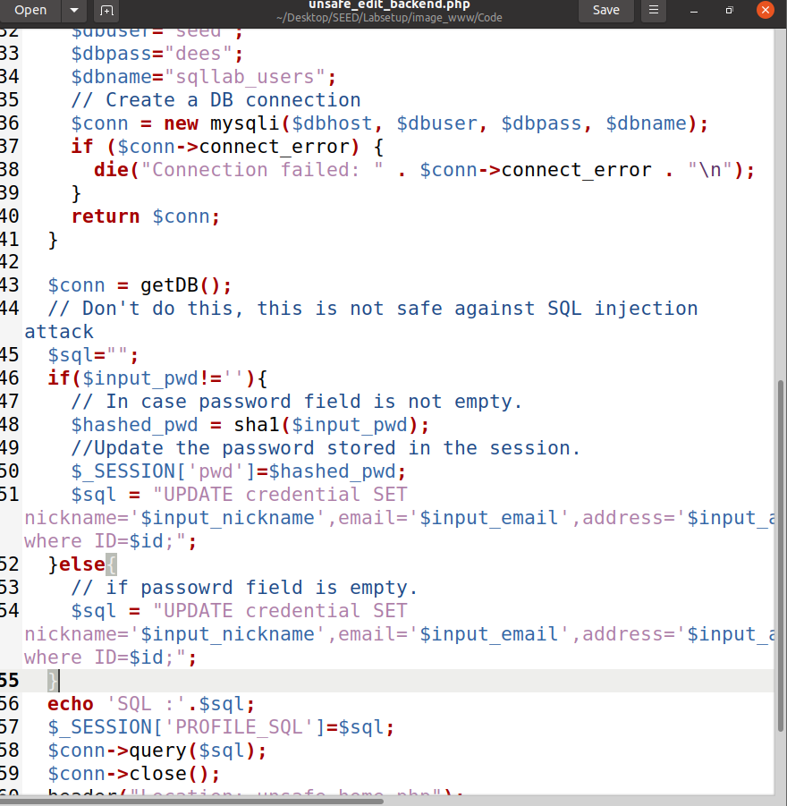

And echoing it in the **unsafe_home.php** file.

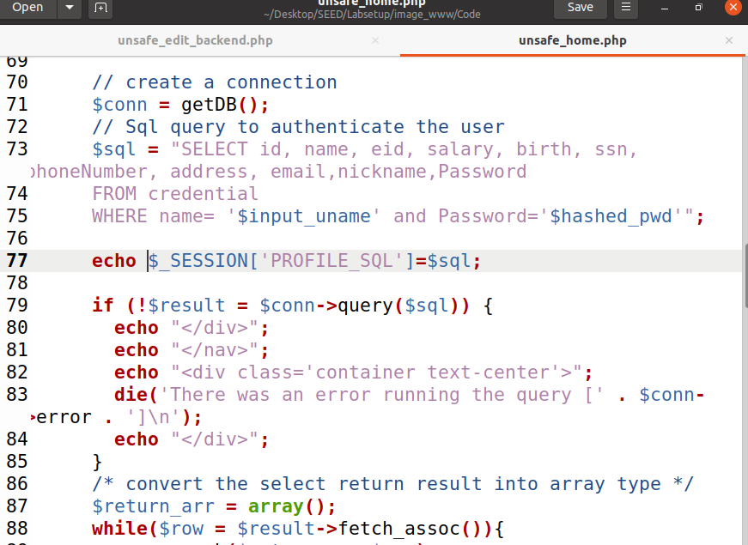

Another modification in the file **unsafe_home.php** on line 267.

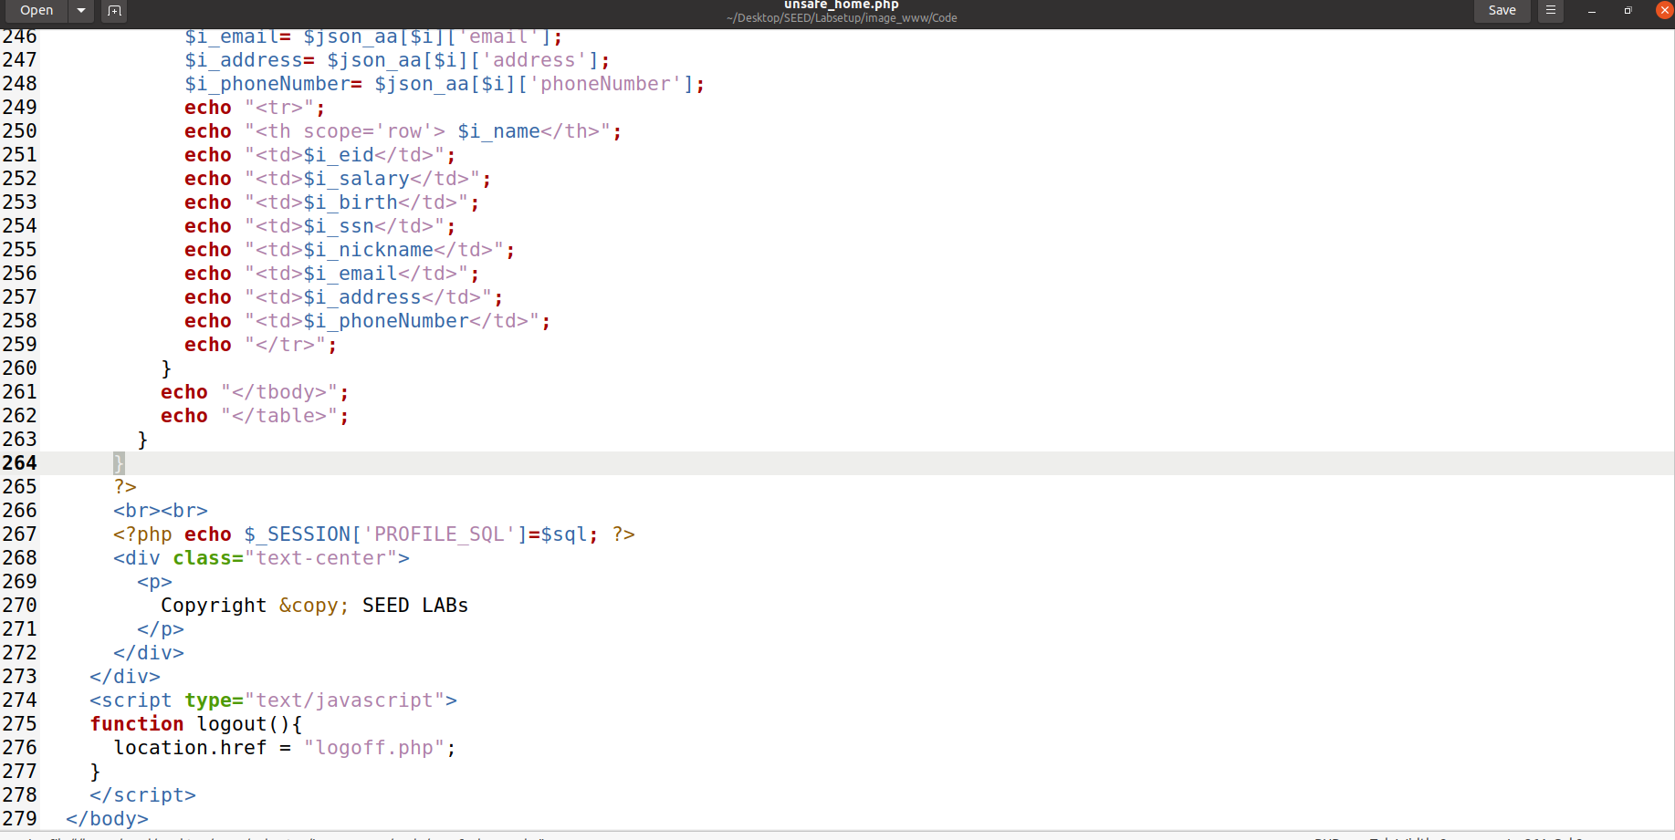

Finally copying the modified files to the Web continer.



Based on these code lines I have found the vulnerability where I can add salary as a parameter as a part of SQL statement which is a part of the database used here.

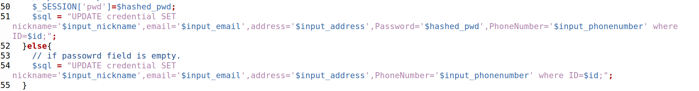

Sending the query.

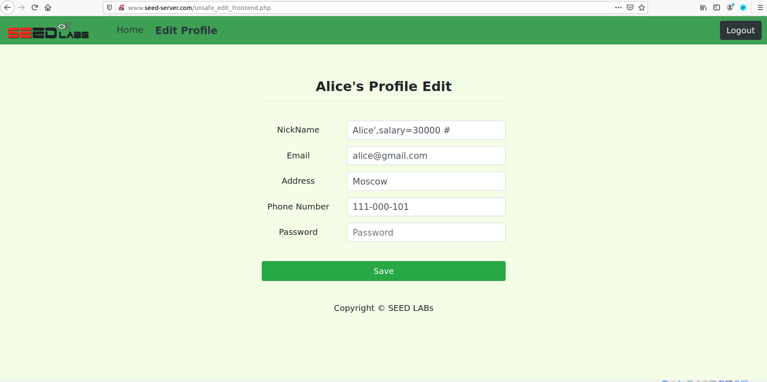

And the salary has been changed from 10,000 to 30,000.

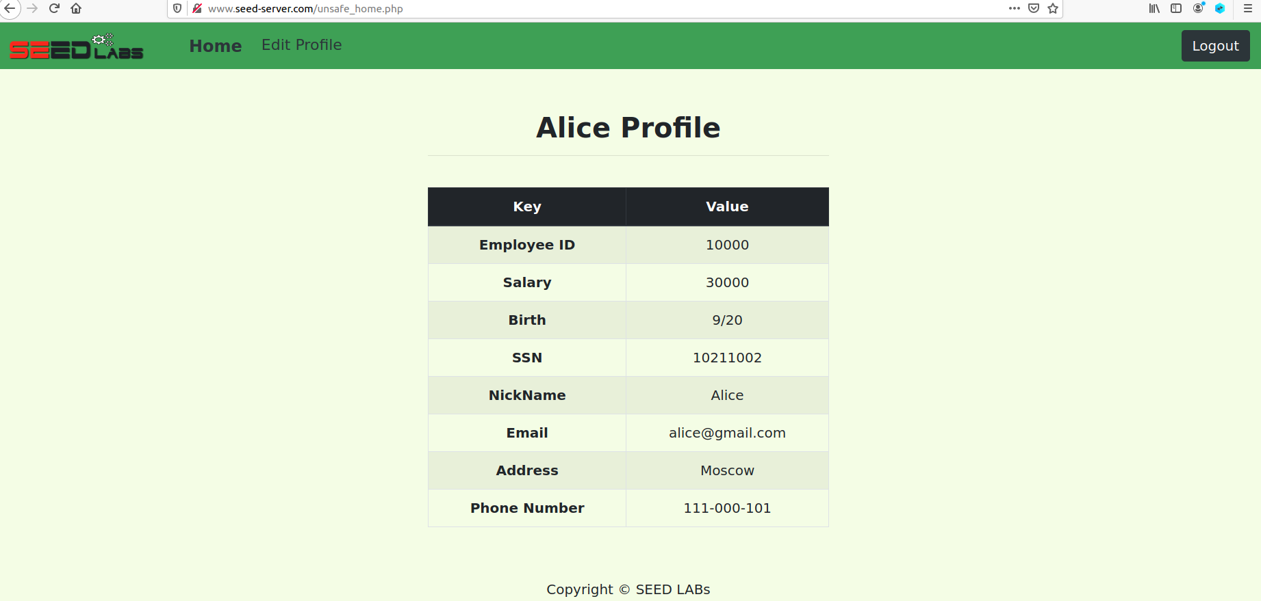

## Task 3.2

Now trying to change Boby’s Salary with the SQL statement **Alice',salary=1 where Name='Boby'; #**

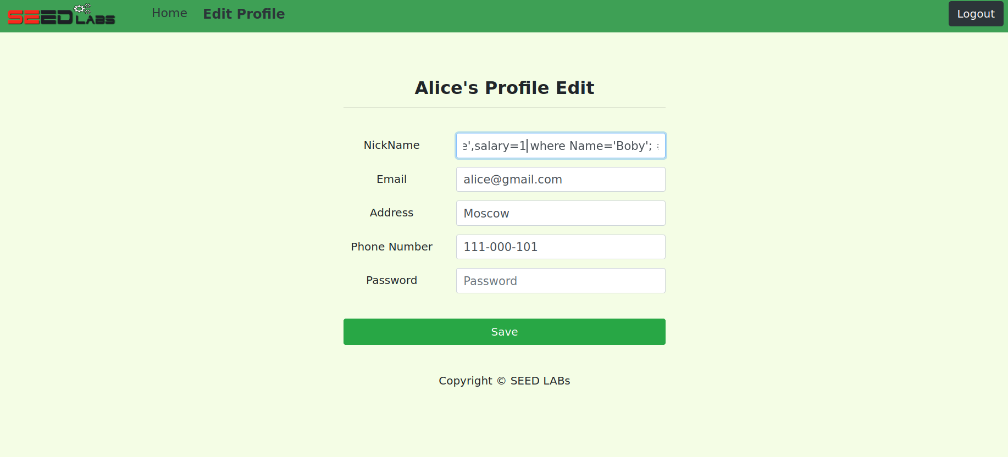

Now in the SQL Database container I have compared the Salary and it has been changed to 1 from 30,000.

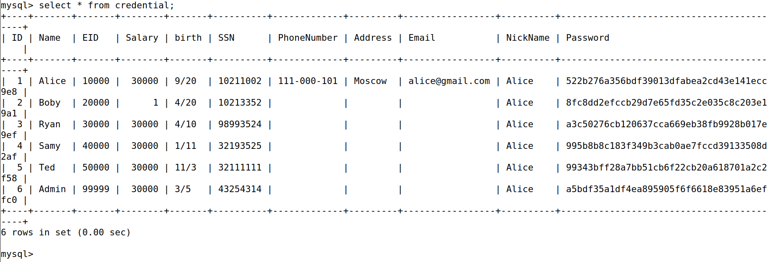

## Task 3.3

Now changing Boby’s password from Alice’s profile with the help of SQL Statement **Alice',password=sha1('boby') where Name='Boby'; #**

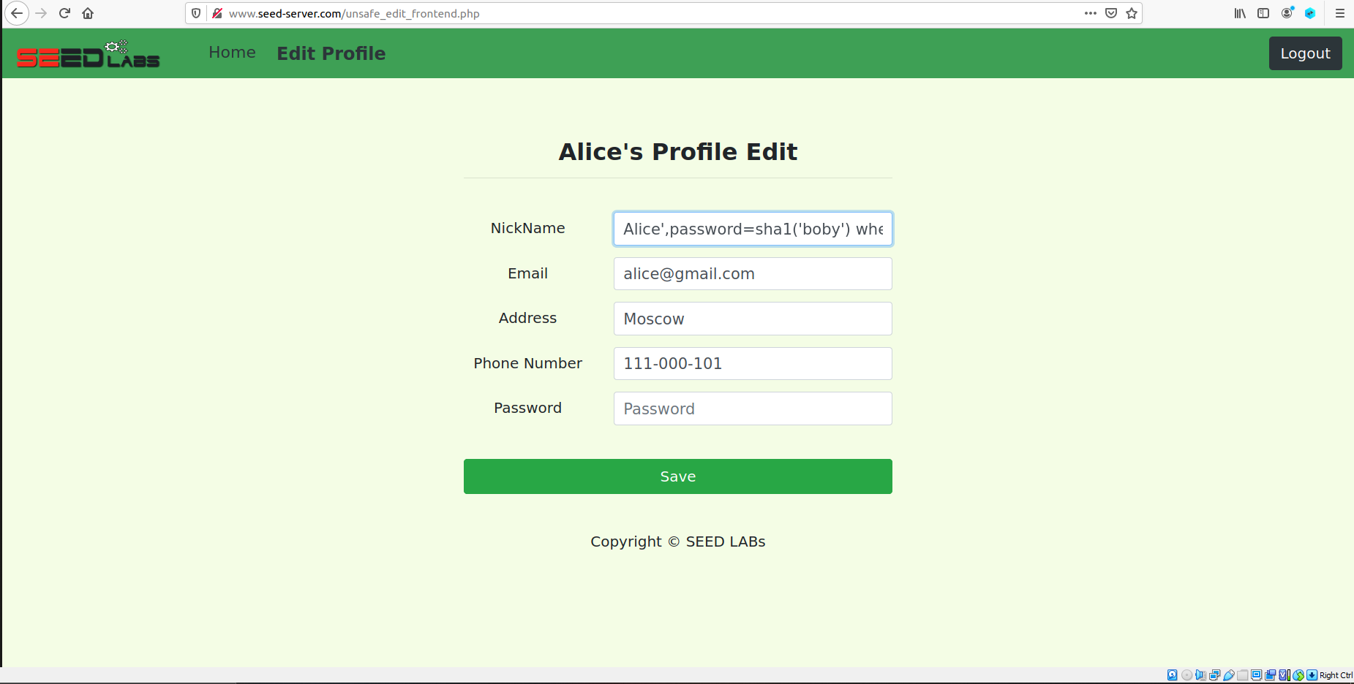

The previous screenshot of the Database is like this.

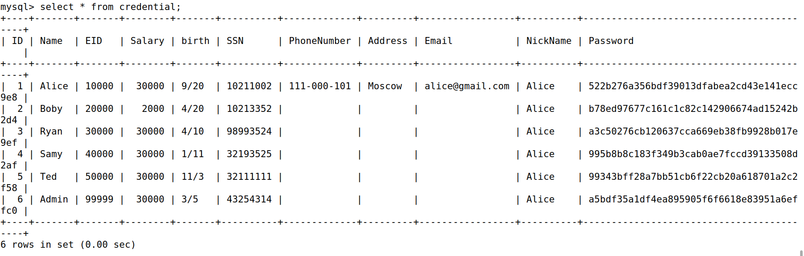

It can be confirmed that the password has been changed by the SQL Database and in the screenshot below it is proven by how the hash of the password is different than what it was before.

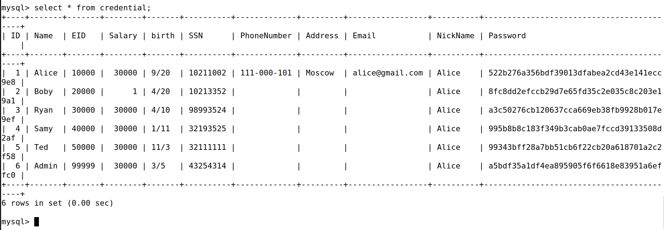

It can also be confirmed with sha1sum which is a match to the change observed in the database.

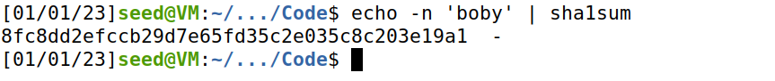

Further confirmation is to login with the changed password set as “boby”.

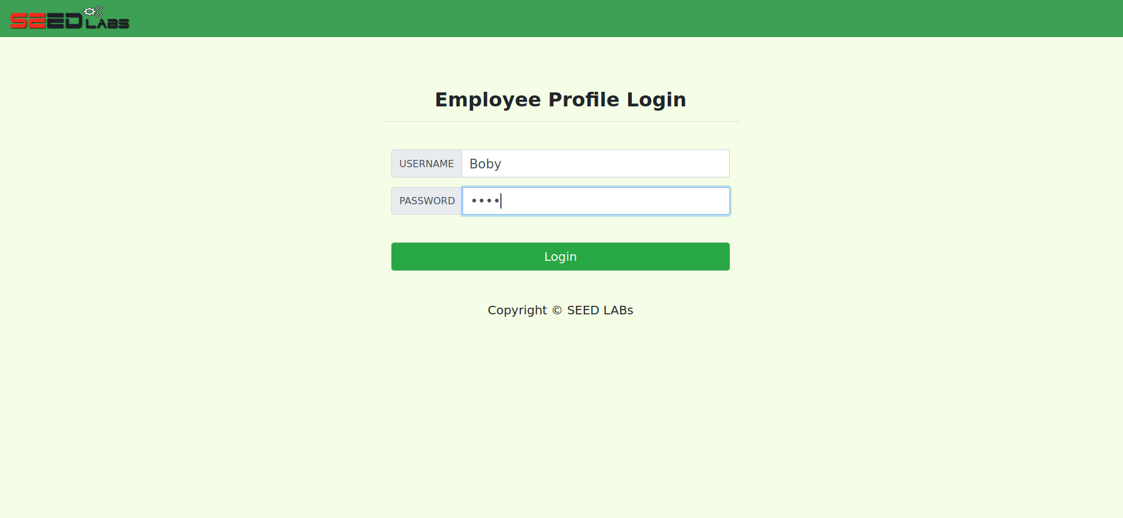

Hence, the task has been completed successfully as the login is successful. Moreover, the salary update performed in previous subtask is also visible.

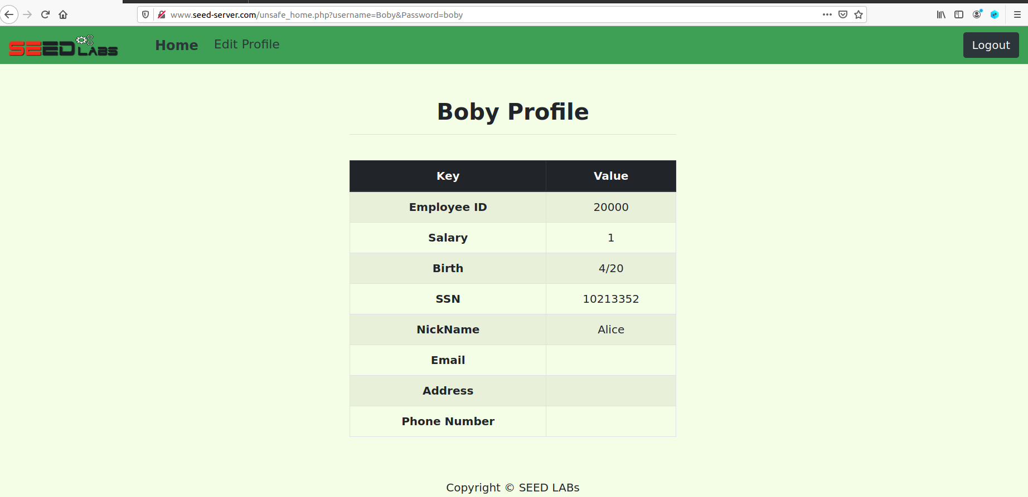

# Task 4

These are the files for the defense of the site.

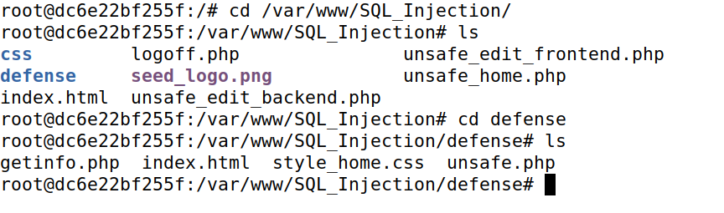

Now visiting the following URL for the task.

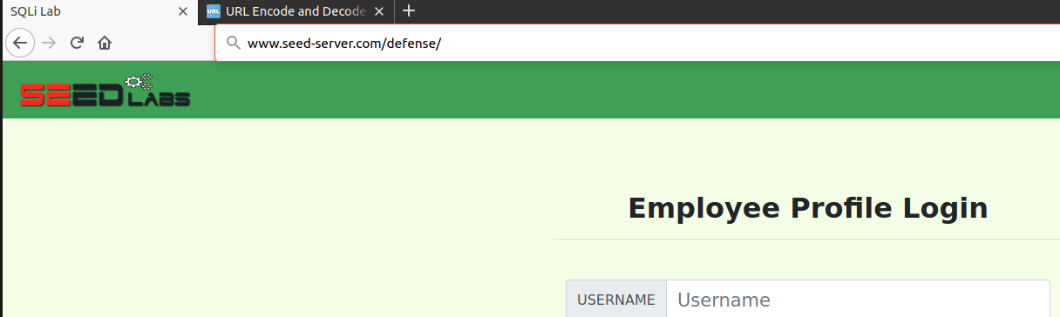

And this is how it looks like.

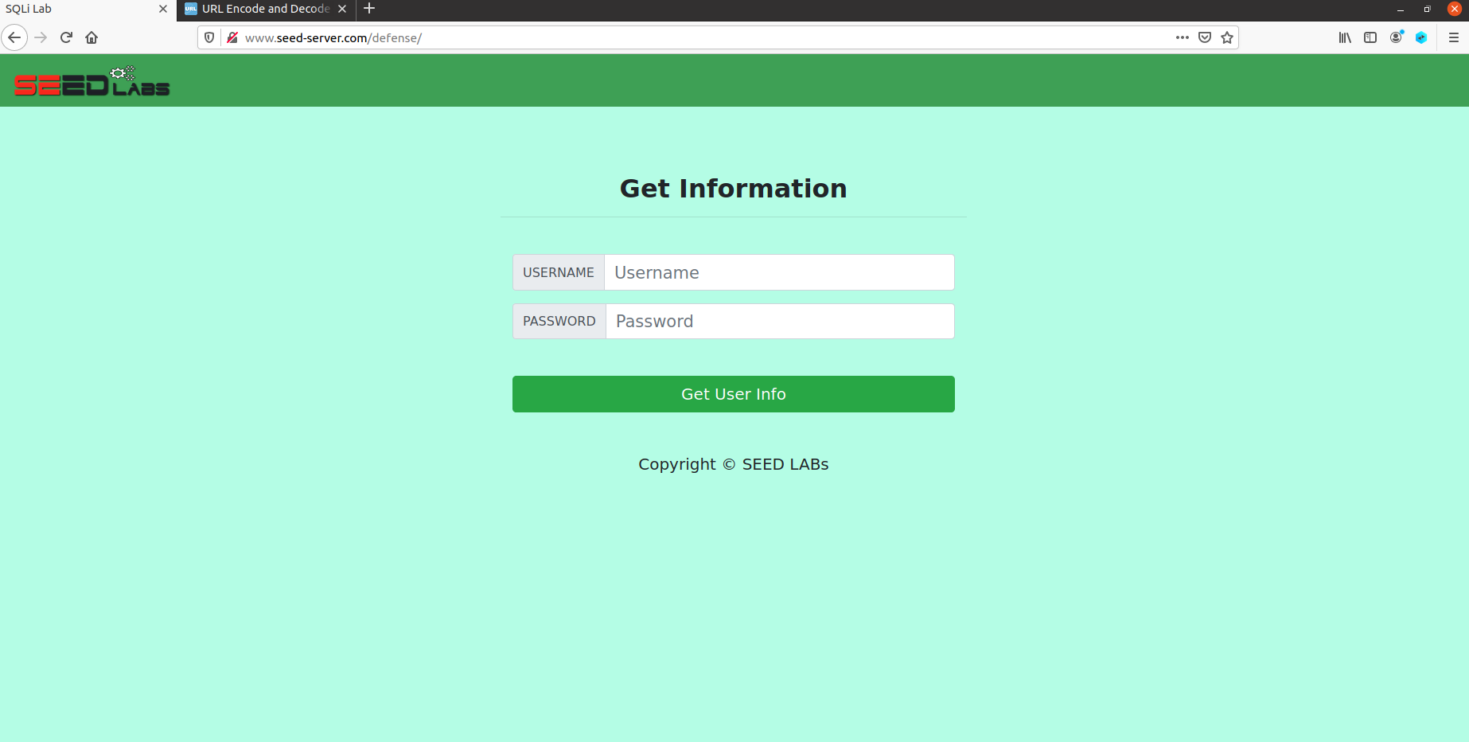

Trying to get user info of Alice.

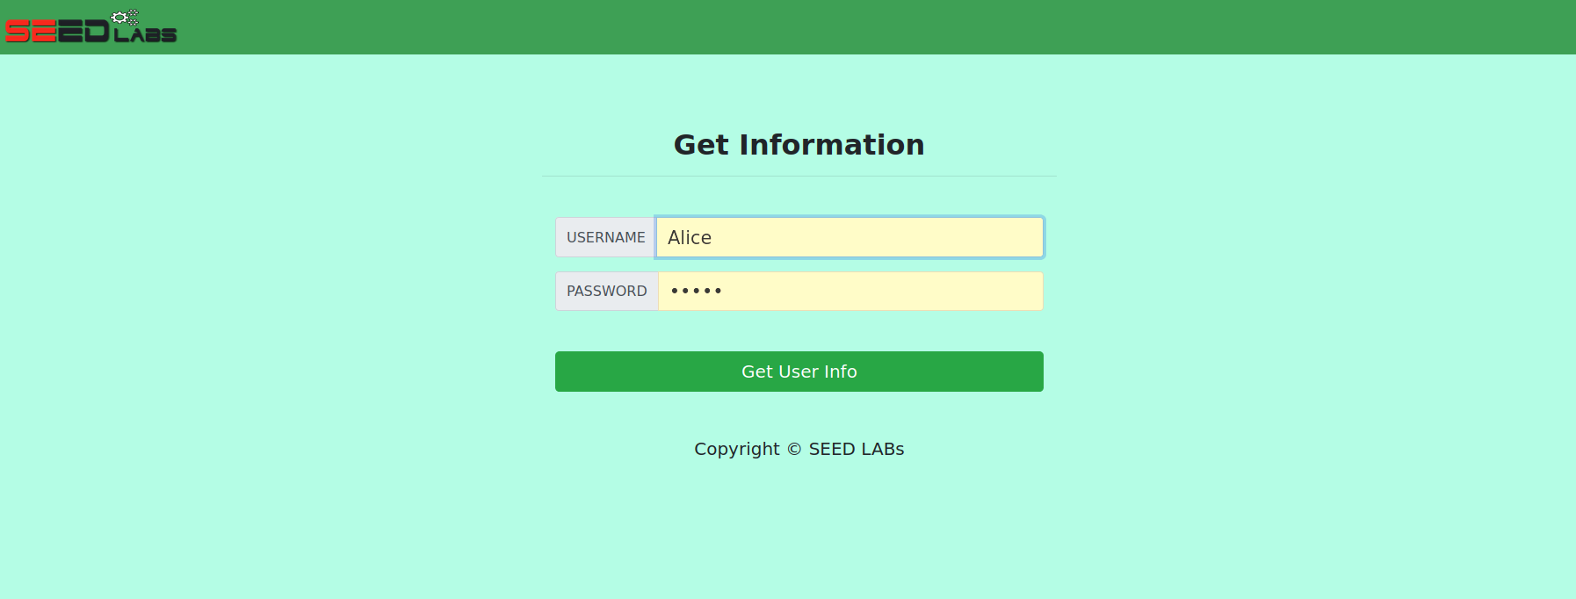

Which is as following as the site accepted Alice’s modified credentials.

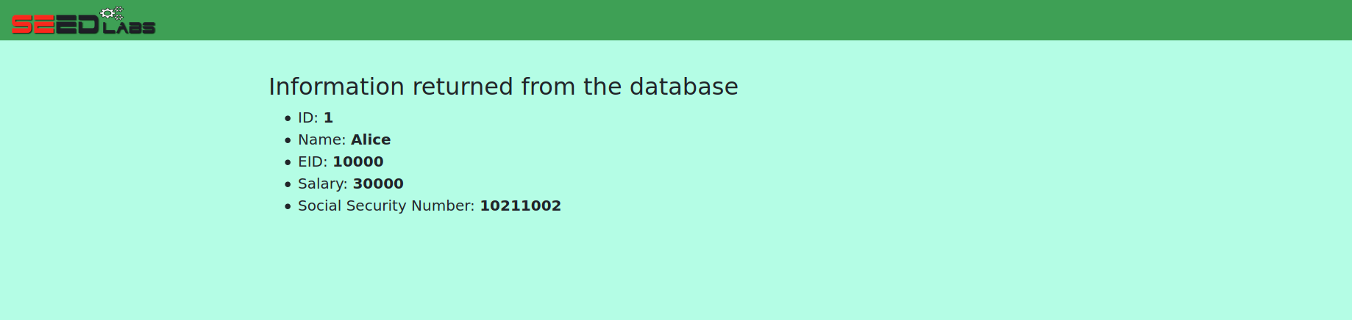

A vulnerability has been spotted in the code of defense site in the **unsafe.php** file. This vulnerability even allows as simple an SQL statement as **Alice’ #**

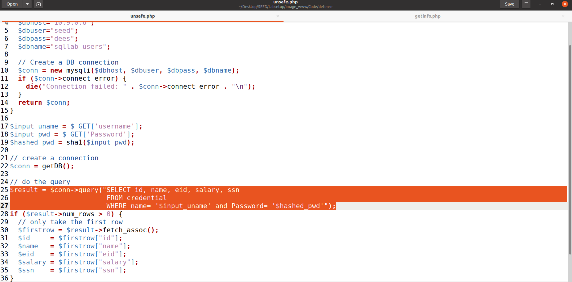

To make prepared statements I have commented the already present vulnerability from line 25 to 38. Then continuing from line 39 I wrote the code where username and password are not just accepted as any input placed in the parameter. Then I bound the parameter with username input and hashed password continuing to the statement where only these parameters will be executed. When executed upon success the user id, name, eid, salary and ssn parameters will be fetched from the database. Finally closing it to prevent anymore vulnerabilities as to include other statements.

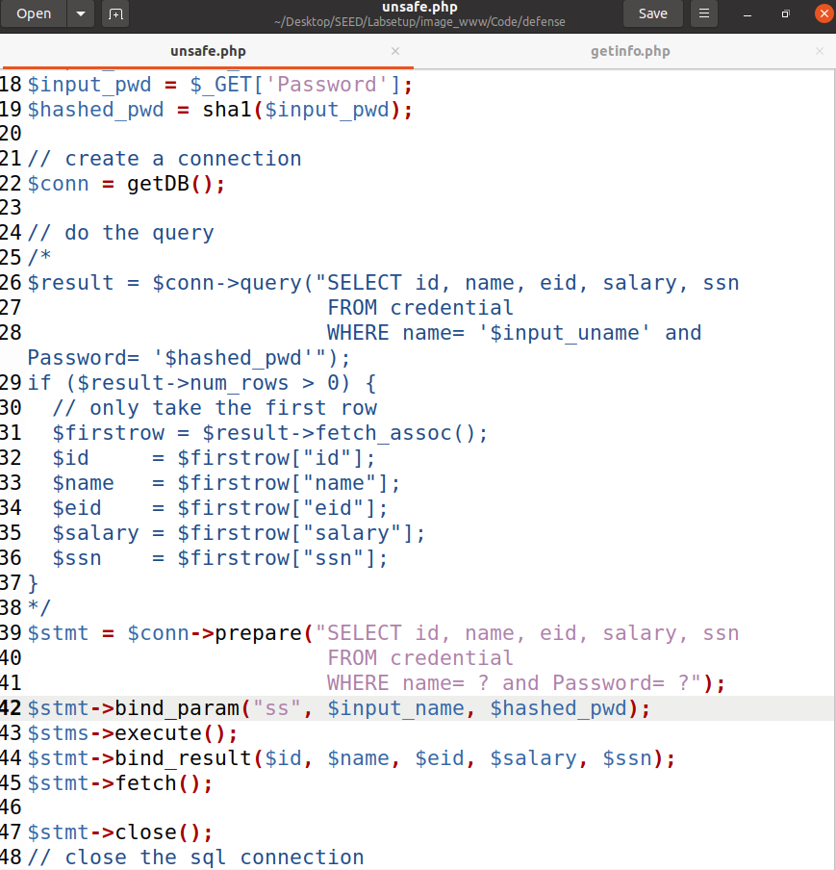

Now copying the **unsafe.php** file to the Web container in the defense folder.

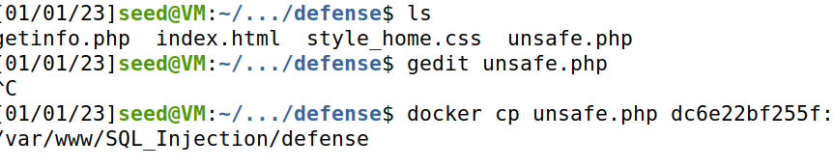

Now trying the attack.

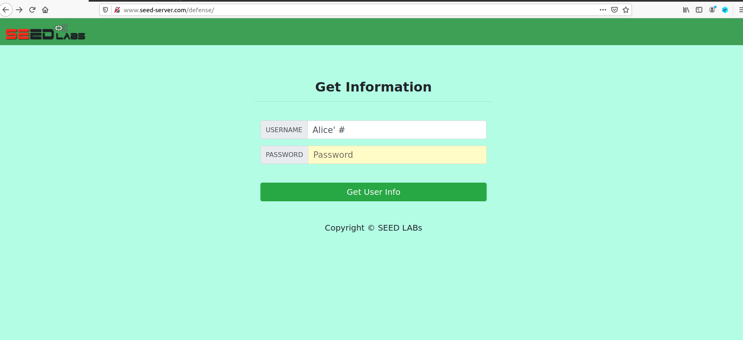

And the attack didn’t work as nothing appeared which is more like no result and closed.

